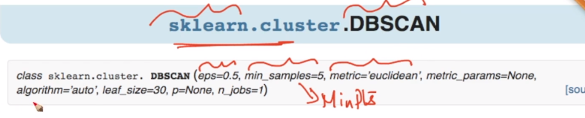

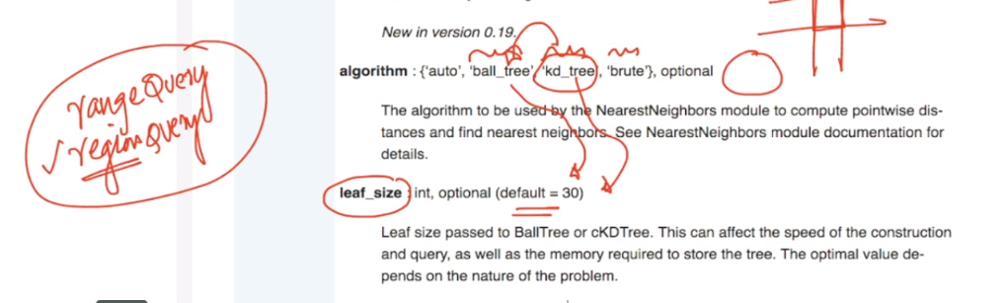

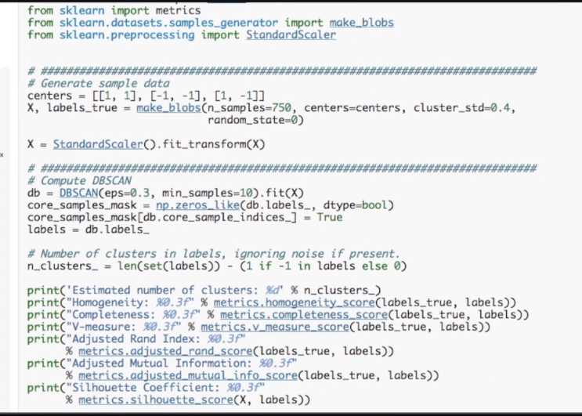

<https://scikit-learn.org/stable/modules/generated/sklearn.cluster.DBSCAN.html>

<https://scikit-learn.org/stable/auto_examples/cluster/plot_dbscan.html#sphx-glr-auto-examples-cluster-plot-dbscan-py>